**Task 3**

**Que 1:** JSON iterate over all for loops

Ans:

let object=[

{"person":"John","age":30,"company":"Google"},

{"person":"Mohn","age":37,"company":"Flipkart"},

{"person":"Kohn","age":38,"company":"Amazon"},

{"person":"Sohan","age":40,"company":"Myntra"},

{"person":"Jenny","age":70,"company":"Apple"},

]

1. **For of loop**

**Code:**

for (let value of object){

console.log(value)

}

**Output**

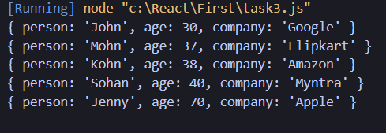

1. **For in Loop:**

**code:**

for (let key in object) {

let value = object[key];

console.log(key, value);

}

**Output:**

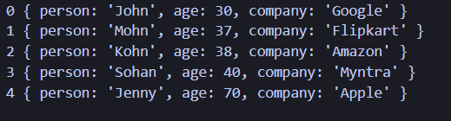

1. **forEach Loop:**

Code:

object.forEach((value) => {

console.log(value);

});

**Output:**

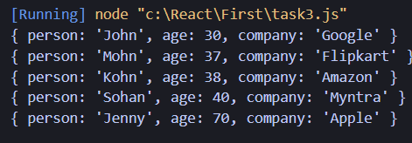

1. For Loop

Code:

for (let i=0; i<object.length; i++){

console.log(object[i])

}

Output:

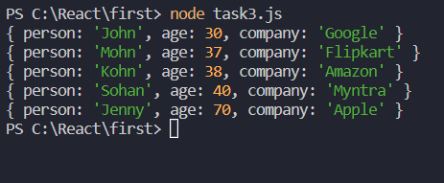

Que 2 : Resume in JSON

let Resume=[

{"Name":"Murgesh Shivkumar Ekunde",

"age":25,

"Qualification":"B.E. Mechanical",

"Skiils" : "Javascript, HTML, CSS, Typescript, ReactJS",

"Hobbies": "Playing games, Writing Blogs ",}

]